Manpreet Kaur UOB 20024046
Question:
A1: Define the concepts of actor and use case
Answer: use cases captures the functionality of system from user viewpoint, use case exist in system boundary, there can be many use cases in the given system, use case interact with actor. Actor is a human or external device user, and might be second system. Actor is going to interact with the use case by communication association relationship, the associated relationship used by the user to interact with the use case. Actor is interact with the use case which is bounded by the system boundary. There are two types of actor such as primary actor and secondary actor, primary actor gives the first input to the system to activate the system which is known as primary actor, because system is in null state nothing to do. The system is active and responds them then there is lot of actor interact with the system which is known as secondary actor.
A2: Identify the actors and list them
Answer:
- Module_Coordinator
- Student
- Supervisor

A3: Draw a use case diagram showing the use cases, the actor and their relationship as described by the scenario?
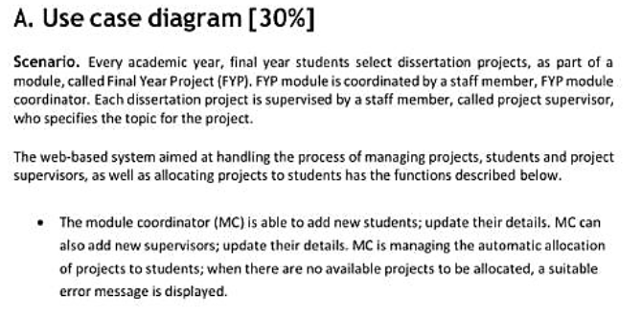
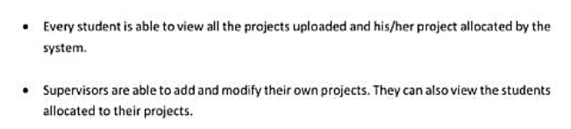
Answer: First Use Case: Module Coordinator
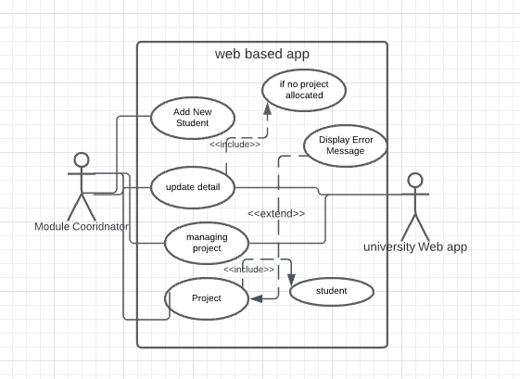
Figure 1: Use case diagram (Module Coordinator)

Description:
Module coordinator is part of university corresponding which communicate between student and supervisor to manage project in the system. The task has been performed by the module coordinator which would be based on the add student, update their detail, manage project if there is no project allocation it will update the project detail and project is not allocated by the student to system It will through exception handling message to module coordinator. The relationship mapping has been allocated with the university use actor system.
Second Use Case: Student
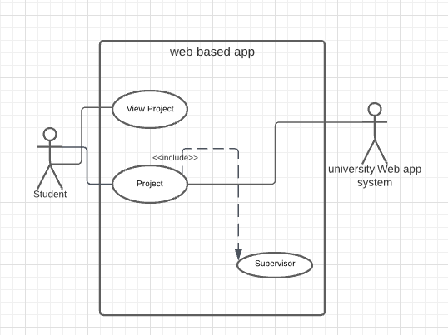
Figure 2: Use Case diagram of Student
Description:
Student is able to view their project which is allocated by the university system. All project approved by the supervisor with instruction from module coordinator. And student project is being supervised by the project supervisor. The relationship is associated with university system clearly shown in use case diagram.
Third Use Case: Supervisor
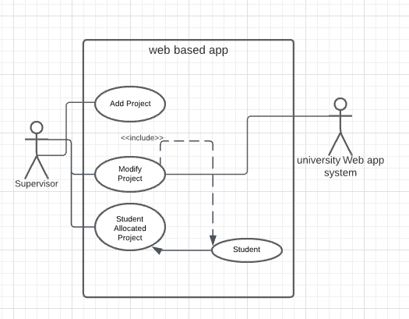
Figure 3: Use Case diagram of supervisor
Description:

Supervisor is able to add and view project allocated by the university system, which is assigned from department Dean & heads. University system is associated with the supervisor and managed the student project and assign any task relating to project to student. Supervisor is able to modify their project detail, and student is allocated project from the system. The relationship in between the supervisor and system is generalized in use case diagram.
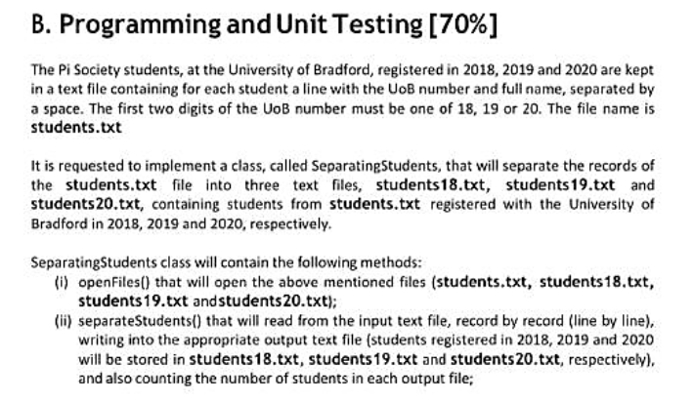
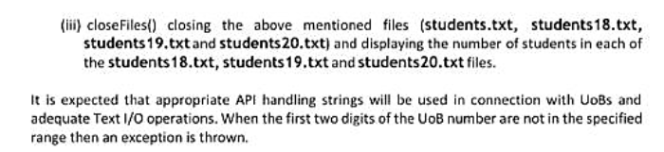
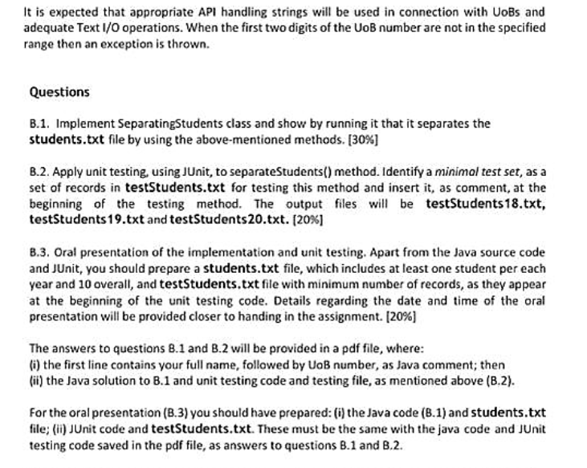

Question B1: Answer
Task 1:
Open file that will open files students .txt student 2018, student 2019, and student 2020.
Separate students
Close files
Open file
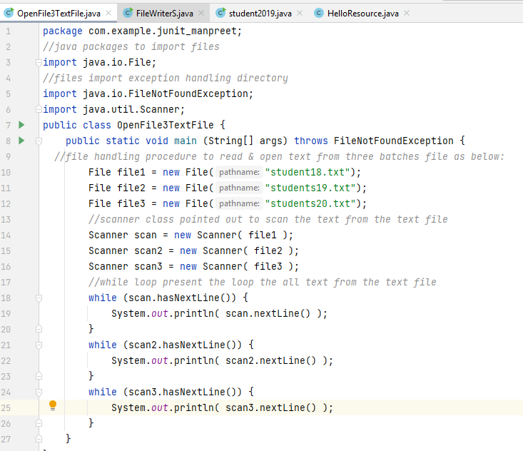
Output:
Welcome PI Society Student at Univesity of Bradford Registred in 2018
student2018 = Mr John UOB 18-46234234
student2018 = Mr Jibran UOB 18-6566555
student2018 = Mr tony UOB 18-456456645
student2018 = Mr Ramdeep UOB 18-1232312312
Welcome PI Society Student at Univesity of Bradford Registred in 2019
Student2019 = Mr william UOB 19-33523423
student2019 = Ms Manpreet UOB 19-20024046
student2019 = Ms Manveer UOB 19-45456456456
student2019 = Ms Ramzeen UOB 19-78979789879
Welcome PI Society Student at Univesity of Bradford Registred in 2020
Student2020 = Mr Kaish UOB 20-2345234234
student2020 = Mr KUPPU UOB 20-64545456646
Creating New File in java
Task 2:
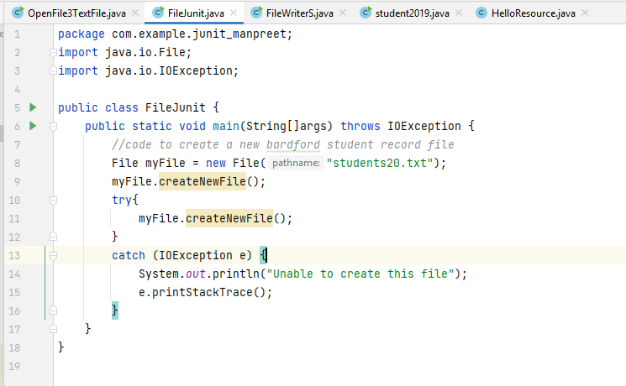

Task 3:
Writing text to file using file writer in java
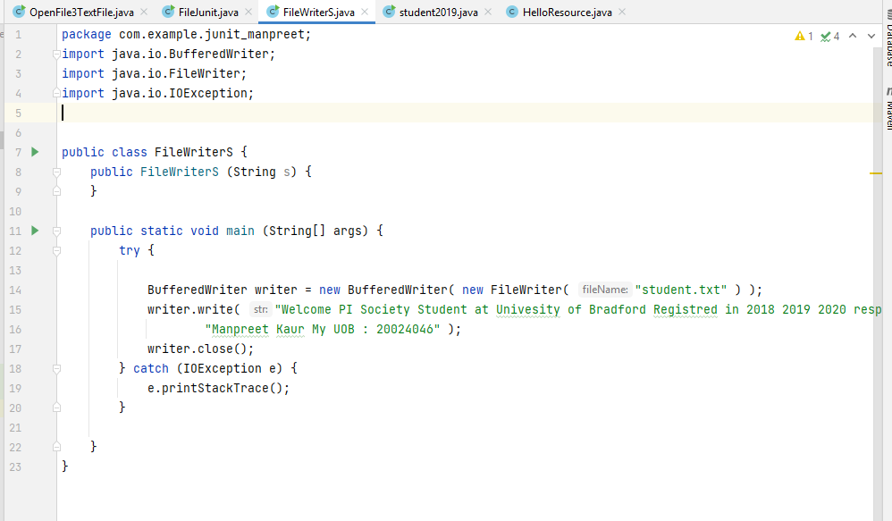

Task 4: Separating student testing file to separate text of 3 student UOB number of 2018, 2019 and 2020 as follows:
Separating Student Java Class Separate student UOB number in separate file
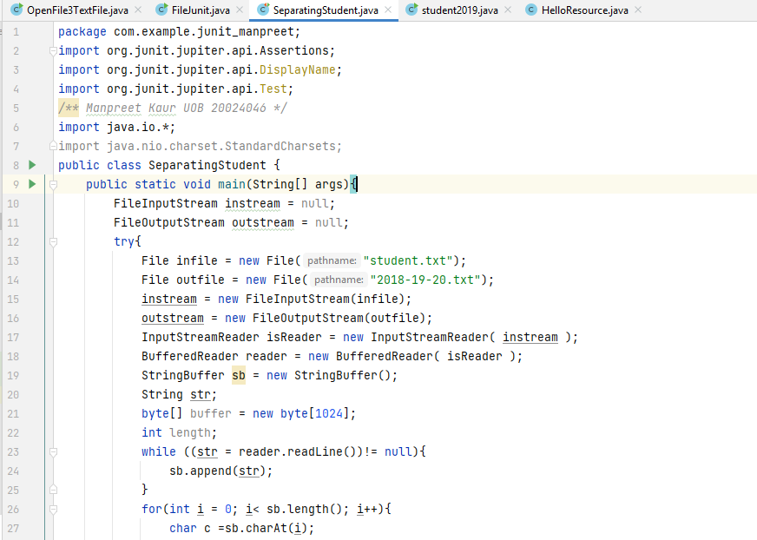
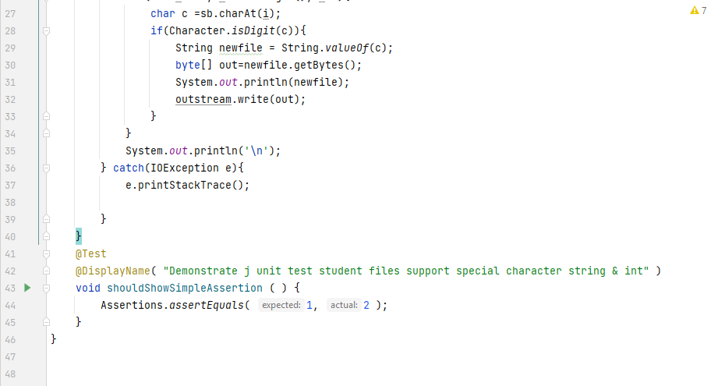
XML file configuration to add J Unit dependencies in Intellij idea
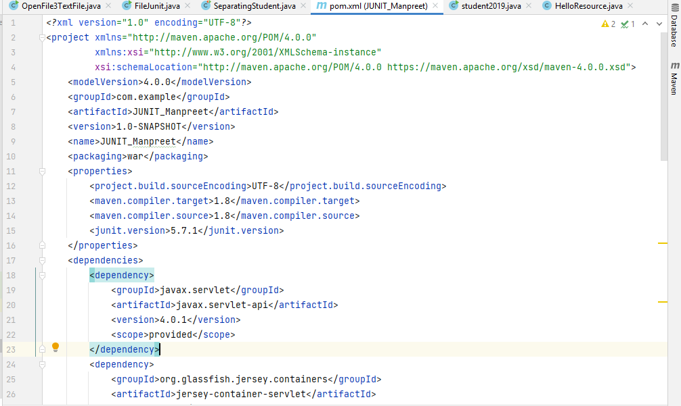
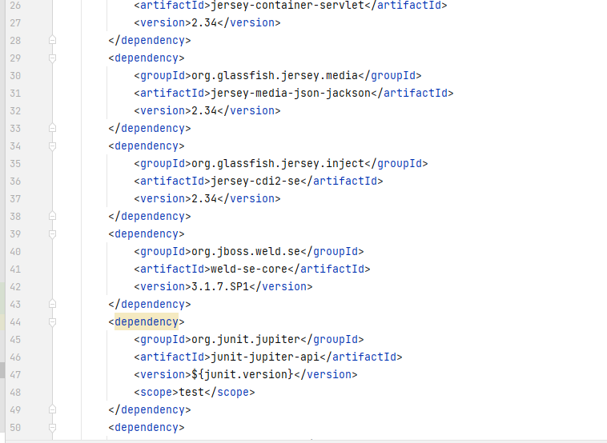
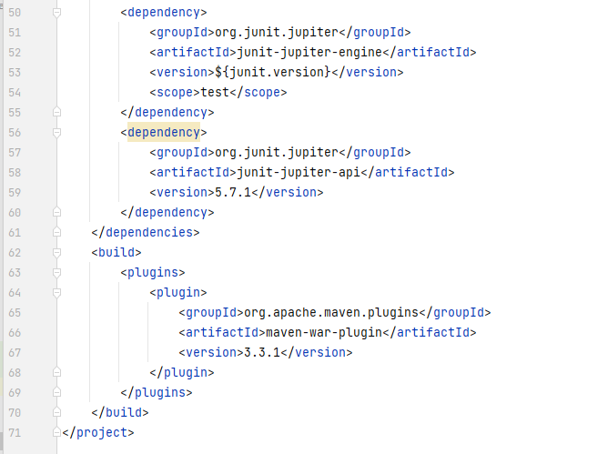
Student.txt file
Welcome PI Society Student at University of Bradford Registered in respectively
Manpreet Kaur My UOB : 20024046
student2018 = Mr. John UOB 18-46234234
student2018 = Mr. Jibran UOB 18-6566555
student2018 = Mr. tony UOB 18-456456645
student2018 = Mr. Ramdeep UOB 18-1232312312
Student2019 = Mr. william UOB 19-33523423
student2019 = MS Manpreet UOB 19-20024046
student2019 = MS Manveer UOB 19-45456456456
student2019 = MS Ramzeen UOB 19-78979789879
Student2020 = Mr. Kaish UOB 20-2345234234
student2020 = Mr. KUPPU UOB 20-64545456646
Student 2018 txt file
Welcome PI Society Student at Univesity of Bradford Registred in 2018
student2018 = Mr. John UOB 18-46234234
student2018 = Mr. Jibran UOB 18-6566555
student2018 = Mr. tony UOB 18-456456645
student2018 = Mr. Ramdeep UOB 18-1232312312

Student 2019 txt file
Welcome PI Society Student at Univesity of Bradford Registred in 2019
Student2019 = Mr. william UOB 19-33523423
student2019 = MS Manpreet UOB 19-20024046
student2019 = MS Manveer UOB 19-45456456456
student2019 = MS Ramzeen UOB 19-78979789879

Student 2020 txt file
Welcome PI Society Student at University of Bradford Registered in 2020
Student2020 = Mr. Kaish UOB 20-2345234234
student2020 = Mr. KUPPU UOB 20-64545456646

Separate text file output 2018, 2019, 2020
Fetching UOB text number of students from separate student java class
The output is given below:

20024046201818462342342018186566555201818456456645201818123231231220191933523423201919200240462019194545645645620191978979789879202020234523423420202064545456646
Question B2:
Task 5:
Answer:
J-UNIT Testing performing on Separating Student Class Separate student UOB number in separate file
